##### Shoulder bag

shoulder bag in white

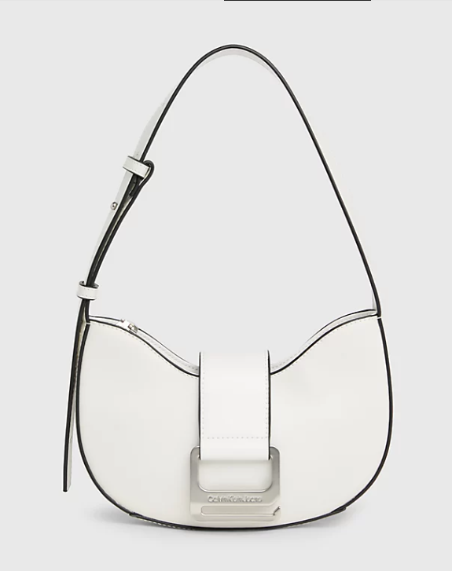  
A white shoulder bag can be a stylish and versatile accessory for various occasions. Whether you're looking for something sleek and modern or more casual and functional, there are plenty of options available. You might consider checking out brands like Michael Kors, Kate Spade, or Coach for elegant designs, or explore more affordable options from retailers like H&M or Zara. Online marketplaces like Amazon or Etsy also offer a wide range of choices from different sellers. Don't forget to consider factors like size, material, and features (such as pockets or compartments) to ensure the bag meets your needs and style preferences.